European Projects Semester Autumn 2022

Building a low-cost and IoT-based weather station

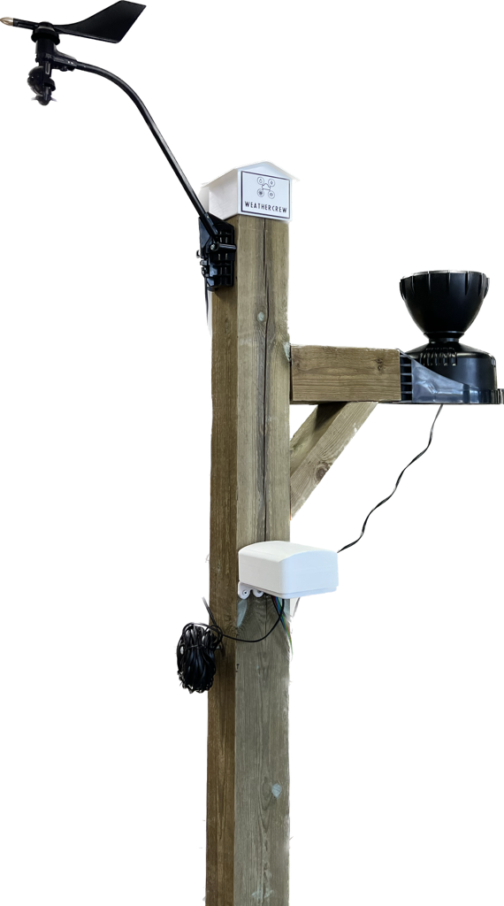

**Authors:**

Antonin Silvestre

Bryan Arents

Chantal Tijhuis

Job van Koeveringe

**Supervisors:**

Hans Lindén

Roger Nylund

**University:**

Novia University of Applied Sciences

**Date and location:**

Autumn 2022, Vaasa

# Abstract

University of Applied Science Novia has had several weather stations throughout the years. Since additive manufacturing and data transfer is getting better and more popular each year, Hans Lindén provided a project to create a new weather station. The goal of this project is to build a low-cost IoT weather station at Novia UAS that is solar-powered and has wireless data transfer to the MQTT broker. Besides that, minimal power should be consumed. The final weather station should be able to measure wind speed, wind direction, temperature, relative humidity and rainfall. As an extra feature, the snow depth and light should be measurable. First, research should be done to reach the goal. After the research, a start will be made on designing and coding. This will lead to the assembling of the weather station. All the relevant information will be documented in a report. Eventually, a look will be given on the final weather station, which will lead to suggested improvements and conclusions.

# Acknowledgement

We would like to express our great appreciation to thank Hans Lindén for his support in this project as a group counsellor. His help really got us on a good starting path and helped us continue this project. Furthermore, we would like to thank Novia University of Applied Sciences for housing the EPS project here in Vaasa and we want to thank all the teachers for teaching us new things and helping us out. At last, our grateful thanks are extended to each other for being a good team member and giving the support needed.

# Preface

This report is about building a moveable weather station that is connected via a 5G mobile network. The first version is a prototype weather station that is built with purchased modules. For example, the Davis wind speed/direction sensor, the Davis rain sensor and the Wal-front temperature sensor. The sensors will be connected to an Arduino.

The second version will be an improvement of the first version. The second one will have self-designed modules. This will keep the total cost of the weather station low. Also, there will be some design improvements.

Table of Content

I. Abstract 1

II. Acknowledgement 2

III. Preface 3

Table of Content 4

List of figures 7

List of tables 8

List of ABbreviations 9

List of symbols 9

1. Introduction 10

1.1 European Project Semester 10

1.2 Meet the projectteam 11

1.2.1 Bryan Arents – The Hague, The Netherlands 11

1.2.2 Job van Koeveringe - 's-Hertogenbosch, The Netherlands 12

1.2.3 Chantal Tijhuis – Enschede, The Netherlands 13

1.2.4 Antonin Silvestre – Manosque, France 14

1.3 Team role assessment and allocation 15

1.3.1 Belbin test 15

1.3.2 Leadership test 17

1.4 Project Management 18

1.4.1 Stakeholders 18

1.4.2 Risk management 19

1.4.3 Work breakdown structure 20

1.4.4 Gantt chart 21

2. Analyse phase V1 23

2.1 Problem statement 23

2.1.1 What? 23

2.1.2 When? 23

2.1.3 Who? 23

2.2 Questions and actions 24

2.2.1 General 24

2.2.2 Sensor 24

2.2.3 Programming 24

2.2.4 Design 24

2.3 Answers 25

2.3.1 General 25

2.3.2 Sensor 31

2.3.3 Programming 34

2.3.4 Design 34

2.4 Logo 35

2.5 Future vision 35

3. Idea phase V1 36

3.1 Problems 36

3.1.1 General lay-out 36

3.1.2 mounting station 37

3.1.3 Interchangeable 37

3.1.4 Housing 38

3.1.5 Sun protection temperature sensor 38

3.2 Material choice 39

3.2.1 Mounting station 39

3.2.2 Additive manufacturing 40

4. Concept phase V1 41

4.1 Design 41

4.1.1 Marketing 41

4.1.2 General design 43

4.1.3 Mounting base 44

4.1.4 Arduino housing 46

4.1.3 temprature sensor housing 49

4.2 Code 50

4.2.1 Wind speed 50

4.2.2 Wind direction 50

4.2.3 Rainfall 51

4.2.4 Temprature and humidity 51

4.2.5 Battery 52

4.2.6 Setup 52

4.2.7 Color cables 53

A. References 54

B. Appendices 56

B.1 DIY weather stations 56

B.2 Material choice 56

# List of figures

Figure 1 Picture of all the Erasmus students of Novia 10

[Figure 2 Bryan Arents 11](https://yhnovia.sharepoint.com/sites/EPSWeatherStation/Delade%20dokument/General/Documents/Weather%20station%20report.docx#_Toc117244042)

[Figure 3 Job van Koeveringe 12](https://yhnovia.sharepoint.com/sites/EPSWeatherStation/Delade%20dokument/General/Documents/Weather%20station%20report.docx#_Toc117244043)

[Figure 4 Chantal Tijhuis 13](https://yhnovia.sharepoint.com/sites/EPSWeatherStation/Delade%20dokument/General/Documents/Weather%20station%20report.docx#_Toc117244044)

[Figure 5 Antonin Silvestre 14](https://yhnovia.sharepoint.com/sites/EPSWeatherStation/Delade%20dokument/General/Documents/Weather%20station%20report.docx#_Toc117244045)

Figure 6 Belbin test scores of the members. Orange is Antonin, yellow is Bryan, green is Chantal and brown is Job. 16

Figure 7 Leadership test scores of the members. Orange is Antonin, yellow is Bryan, green is Chantal, brown is Job and gold is a typical project manager. 17

Figure 8 Stakeholders matrix where the stakeholders each have their own number 18

[Figure 9 Work Breakdown Structure (WBS) with the phase, each delivery and the tasks 20](https://yhnovia.sharepoint.com/sites/EPSWeatherStation/Delade%20dokument/General/Documents/Weather%20station%20report.docx#_Toc117244049)

[Figure 10 Dimensions mounting point 25](https://yhnovia.sharepoint.com/sites/EPSWeatherStation/Delade%20dokument/General/Documents/Weather%20station%20report.docx#_Toc117244050)

Figure 11 Display of professional weather stations 26

Figure 12 Display of amateur weather stations 28

Figure 13 Display of an Arduino MKR NB 1500 32

Figure 14 Closer look on the function of the Arduino with information about each pin 33

Figure 15 Display of the group’s logo 35

Figure 16 General lay out sketch 36

Figure 17 Mounting station designs 37

Figure 18 Housing for the sensors 38

[Figure 19 Wood used 39](https://yhnovia.sharepoint.com/sites/EPSWeatherStation/Delade%20dokument/General/Documents/Weather%20station%20report.docx#_Toc117244059)

[Figure 20 Concrete used 39](https://yhnovia.sharepoint.com/sites/EPSWeatherStation/Delade%20dokument/General/Documents/Weather%20station%20report.docx#_Toc117244060)

[Figure 21 Steel used 39](https://yhnovia.sharepoint.com/sites/EPSWeatherStation/Delade%20dokument/General/Documents/Weather%20station%20report.docx#_Toc117244061)

Figure 22 Marketing house 41

[Figure 23 shows the first poster that has been made for marketing 42](https://yhnovia.sharepoint.com/sites/EPSWeatherStation/Delade%20dokument/General/Documents/Weather%20station%20report.docx#_Toc117244063)

Figure 24 General design 43

Figure 25 Mounting base drawing 44

Figure 26 Mounting base 45

Figure 27 V1 Arduino housing 46

Figure 28 V2 Top Arduino housing 47

Figure 29 V2 Arduino housing 47

Figure 30 V2 Arduino housing 48

Figure 31 Temperature sensor component 49

[Figure 32 Temperature housing top and bottom 49](https://yhnovia.sharepoint.com/sites/EPSWeatherStation/Delade%20dokument/General/Documents/Weather%20station%20report.docx#_Toc117244072)

# List of tables

Table 1 Belbin team roles with description 15

[Table 2 Risk register with information about each individual risk 19](https://yhnovia.sharepoint.com/sites/EPSWeatherStation/Delade%20dokument/General/Documents/Weather%20station%20report.docx#_Toc117243772)

Table 3 List of tasks that needs to be done during the project 21

Table 4 Overview of all the task for the project with the responsible people and the deadline 22

Table 5 Professional examples of weather stations 27

Table 6 Amateur examples of weather stations 29

Table 7 Additive manufacturing filament and their advantages 40

Table 8 DIY YouTube videos given with some information 56

Table 9 Materials and their properties 56

# List of ABbreviations

|  |  |
| --- | --- |
| Abbreviation | Definition |
| EPS | European Semester Project |
| UAS | University of Applied Sciences |
| IoT | Internet of Things |
| NB-IoT | Narrowband Internet of Things |
| LTE-M | Long Term Evolution for Machines |
| MQTT | MQ Telemetry Transport |
| DIY | Do it yourself |
| 3D | Three-dimensional |
| V1 | Version 1 |
| V2 | Version 2 |
| PLA | Polylactic acid |
| ASA | Acrylic styrene acrylonitrile |
| PETG | Polyethylene terephthalate glycol |
| UV | Ultraviolet |
| CNC | Computer Numerical Control |
| AWS | Amazon Web Services |
| I2C | Inter-Integrated Circuit |

# List of symbols

|  |  |  |
| --- | --- | --- |
| Symbol (Unit) | Definition | SI |
| mm | One thousandth of a metre | millimetre |
| V | Electrical potential and electrical voltage | voltage |

# Introduction

In this chapter information about the EPS, the members and the project can be found. Moreover, the stakeholders, risks and the Gantt chart will be shown.

## European Project Semester

‘European Project Semester (EPS) is a programme offered by several European universities to students who have completed at least two years of study. EPS is created with engineering students in mind, but other students who can participate in an engineering project are also welcome.

EPS is a mixture of “Project Related Courses” and project organized/problem-based learning. It is crafted to address the design requirements of the degree and prepare engineering students with all the necessary skills to face the challenges of today’s world economy. Students work in international and interdisciplinary teams of 3–6 students on their projects. Projects are done in cooperation with commercial businesses and industries or with research centres. There are minor differences between EPS-projects and the various EPS-providers, but all providers have agreed about the following key elements (European Project Semester, 2022).’

This project takes place in Vaasa, Finland. The hosting university is Novia University of Applied Sciences (UAS). This semester, autumn 2022, 5 projects are divided over a group of eighteen students from all over Europe. Mostly Dutch, German, French and Spanish students are partaking. The participating students, plus a few extra Erasmus students, can be seen in Figure 1.

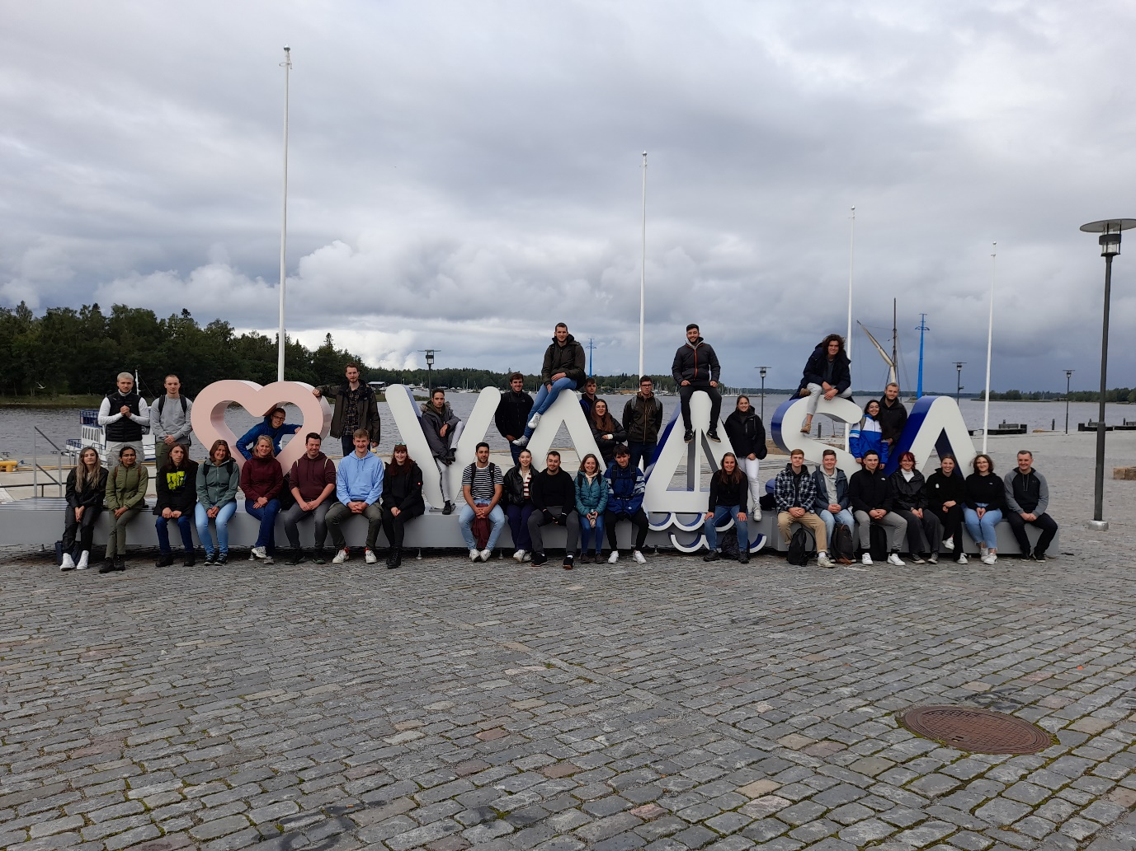

Figure 1 Picture of all the Erasmus students of Novia

## Meet the projectteam

### Bryan Arents – The Hague, The Netherlands

Hello everyone, my name is Bryan Arents. I am from the political capital of The Netherlands, called ‘The Hague’ or in Dutch ‘Den Haag’. My study is also in this city at the ‘The Hague’, University of applied sciences. I studied one year of mechanical engineering and two years of Industrial product design. I am planning to get my bachelor’s in industrial product design, because I really like the broadness of it and I also like the technical creativity combination.

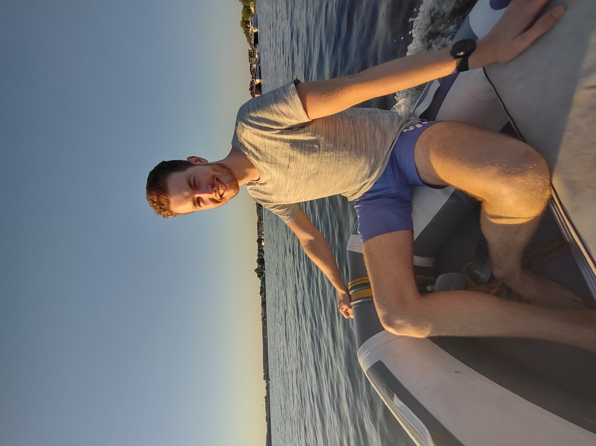I am 21 years old and my hobbies are fitness, all kinds of extreme sports and gaming. I also like to travel, so that’s also one of the reasons I choose to do this European project semester. For example, I also spend the winter in Bonaire during my gap year, so I lived longer by myself outside the country than actually in my own country.

I wanted to do something outside of the country for my Minor, so I looked up my possibilities. Then I found the European Project Semester. Immediately I knew I wanted to do this. I also wanted a project which would be a little bit more on the technical side. That is where Finland came into the picture. I always wanted to go to the Nordic countries, so this was a good opportunity. Also, I am a big fan of nature and snow, so that also suits my pickings. That’s why I choose to do the EPS in Vaasa.

Figure 2 Bryan Arents

I think this project fits me well, because my study is literally designing products. So, designing a weather station fits that nice. Also, I have always been interested in following the weather. For example, checking Windfinder for predicting if the surf will be good. Also, I have a bit of experience working with electronics.

My goals with this project are to broaden my knowledge by working with students from different fields. Also, I would like to extend my English communication skills. Furthermore, I would like to develop even more as a product designer.

### Job van Koeveringe - 's-Hertogenbosch, The Netherlands

Hi, my name is Job van Koeveringe. I’m studying at Avans University of Applied Sciences in ‘'s-Hertogenbosch’, colloquially known as ‘Den Bosch’. Currently I’m in my third year of the study Computer Science. The study covers the objects: Applies the principles of mathematics, e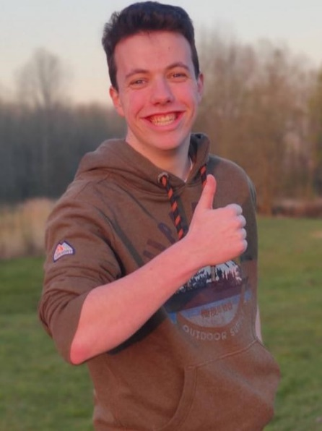ngineering, and logic to a plethora of functions, including algorithm formulation, software and hardware development, and artificial intelligence.

I am 21 years old, and my hobbies are: Scouting, travelling, home automation and watching Formula 1. Weekly I accompany a group at my own scouting and several times a year for national events of Scouting Nederland. During the holidays, I love to travel with friends and explore the world. In my free time, I love to expand my home automation with open-source software called Home Assistant. On Formula 1 weekends, I am always watching, and I try to visit at least one race a year.

Figure 3 Job van Koeveringe

For my Minor, I wanted to do something abroad. I had no interest in just taking classes. My interest was to do something study-oriented in a kind of group assignment. The advisor at my home university recommended me to do a European Project Semester. The question now was where am I going to attend the EPS? My preference was for a northern country. The EPS was offered in Norway and Finland. I had already been on holiday to Norway several times. On the other hand, I had never visited Finland. In Norway, the university was in the middle of Oslo; in Finland, the university was in a student town called Vaasa. After some more comparisons, I finally decided to choose Vaasa Finland.

There were six projects to choose from this semester at the EPS. However, among these, there were only two that fell in my study direction. The submarine and the weather station. The submarine would use a Raspberry Pi and the weather station would use Arduino. Since I already had knowledge of Raspberry Pi, I preferred to do something with Arduino. I also would like to have a physical product at the end of the project and with a submarine there was less chance of that. That's why I went for the IoT weather station.

My goals for this project are to learn to work with foreign students on a joint project, each with their own cultural background, to improve my English communication skills and learn the Swedish language. Also, broaden my knowledge of IoT using AWS.

### Chantal Tijhuis – Enschede, The Netherlands

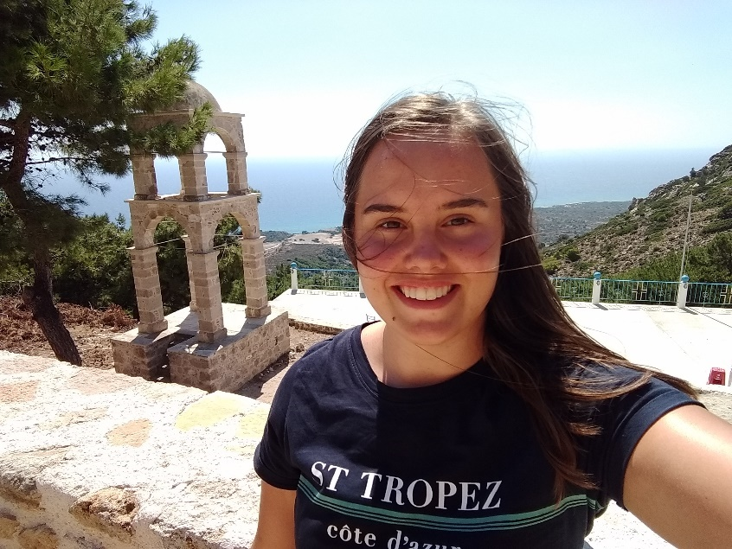Hi! I'm Chantal and I am 21 years old. I’m currently in my third year of the study Applied Physics. I am following this study at Saxion, which is located in Enschede. Applied Physics is a broad study. I learned a bit of thermodynamics, fluid mechanics and heat transfer, mechanics, optics, statistics and more. In this team I may not be able to show a lot of study skills, but I will get the chance to learn a bit more about programming and designing.

Figure 4 Chantal Tijhuis

The hobbies I have outside of school are listening to music, baking, hiking, rollerblading and meeting my friends.

I chose to do the EPS in Vaasa, because I've always wanted to go to a Scandinavian country, which I thought Finland was which is not true, mostly for the differences in seasons. Furthermore, it was a fantastic opportunity. The other option I had is to do the same kind of thing, so a project in a multidisciplinary group, at Saxion or in a different country. Vaasa looked like a nice and not too crowded city, which I really like at the moment. Doing this project outside of my home country can make me learn more about myself, because it is my first time being on my own for a longer period. Furthermore, it is a great opportunity to learn skills from others, not only knowledge, but also social skills.

### Antonin Silvestre – Manosque, France

Hi! My name is Antonin Silvestre. I am 21 years old. I am from Manosque, a small town near Marseille in the south of France. I study at National Engineering school, Tarbes. Currently, I am doing my fourth year of study. My field of study is based on general engineering. I learn mechanical, material science and building engineering.

I applied for the EPS because I really like to work as a team. To me it’s very enriching and it enables me to improve my English. My life is based on challenges and the EPS is a challenge that pushes me out of my comfort zone.

Moreover, EPS is a mix of courses and a project with people from all over Europe. That is perfect to discover new cultures or different way of lives. During my free time I usually do sports, mostly rugby. Furthermore, I like different types of activities that are sport-related, like CrossFit and mountain bike.

Figure 5 Antonin Silvestre

Finally, I choose to do my Erasmus in Finland, because I always wanted to travel to a Nordic country for the snow and its landscapes.

## Team role assessment and allocation

### Belbin test

Researcher Meredith Belbin has identified nine types of behaviours within a work environment. Table 1 shows the different kind of behaviours. Most of the time people will identify to more than one profile. For a team to be most successful, a diverse combination of people’s behaviour is needed (Belbin, 2022).

Table 1 Belbin team roles with description

|  |  |  |  |
| --- | --- | --- | --- |
|  | Team Roles | Contribution | Allowable Weaknesses |
| T  h  i  n  k  i  n  g | Plant | Creative, imaginative, free-thinking. Generates ideas and solves difficult problems. | Ignores incidentals. Too preoccupied to communicate effectively. |
| Specialist | Single-minded, self-starting, dedicated. Provides knowledge and skills in rare supply. | Contributes only on a narrow front. Dwells on technicalities. |
| Monitor Evaluator | Sober, strategic and discerning. Sees all options and judges accurately. | Lacks drive and ability to inspire others. Can be overly critical. |
| A  c  t  i  o  n | Shaper | Challenging, dynamic, thrives on pressure. Has the drive and courage to overcome obstacles. | Prone to provocation. Offends people’s feelings. |
| Implementer | Practical, reliable, efficient. Turns ideas into actions and organises work that needs to be done. | Somewhat inflexible. Slow to respond to new possibilities. |
| Complete Finisher | Painstaking, conscientious, anxious. Searches out errors. Polishes and perfects. | Inclined to worry unduly. Reluctant to delegate. |
| P  e  o  p  l  e | Resource Investigator | Outgoing, enthusiastic, communicative. Explores opportunities and develops contacts. | Over-optimistic. Loses interest once initial enthusiasm has passed. |
| Coordinator | Mature, confident, identifies talent. Clarifies goals. Delegates effectively. | Can be seen as manipulative. Offloads own share of the work. |
| Team worker | Co-operative, perceptive and diplomatic. Listens and averts friction. | Indecisive in crunch situations. Avoids confrontation. |

Figure 6 Belbin test scores of the members. Orange is Antonin, yellow is Bryan, green is Chantal and brown is Job.

With a quick few on the results in Figure 6 it can be said that the members got a lot of roles in common, such as team worker, implementer and coordinator. In the team the roles plant, completer finisher and resource investigator are not prominent. The equal profiles can ensure that little is thought outside the box and that the project will follow one straight line, because the roles not prominent are more creative. Furthermore, equal profiles can mean that sometimes minor frictions can occur. Lot of the members got a higher score on coordinator. With this profile people will mostly lead when needed, which means that if more than one team member takes the lead, discussion may occur. On the contrary, same profiles can complement the group and is essential to achieve an ideal balance for a smooth progress. Moreover, Bryan and Job got shaper and specialist, this means that the group is diverse and well-balanced enough. To make the team more diverse, a resource investigator, a complete finisher, a plant and a monitor evaluator are needed when adding a new team member.

### Leadership test

The leadership skills test helps team members determine a person’s ability to manage, lead and guide others. It should answer whether team members have everything they need to become prominent leaders (Lavri, 2022)*.*

Figure 7 Leadership test scores of the members. Orange is Antonin, yellow is Bryan, green is Chantal, brown is Job and gold is a typical project manager.

From Figure 7 it can be concluded that none of the team members have reached the scores of a typical project manager on every area. Job scored remarkably high on every area though didn’t reach the score for a typical manager at the area of dealing with uncertainty. Compared to the other team members Chantal did not score high on planning, which means she needs someone who can make the planning for her. Antonin scored a little lower on communication, dealing with uncertainty and creative think’ problem solving. Lastly, Bryan scored the lowest on dealing with uncertainty, which can make him keen on planning everything in detail. The differences in each member’s low scores and each member’s high score may lead to good teamwork. In different situations different members of the team will show of their lead ability. Furthermore, learning from others is increased.

## Project management

### Stakeholders

A person or group that has an interest in any decision or action of an organization is the definition of a stakeholder (Smith, 2000). In Figure 8 the stakeholder matrix of the project can be seen. The matrix gives a visual overview of each individual stakeholder and their influence and interest. The overview is made more organized by putting in four different quadrants.

1. Manage Closely: The stakeholder has high influence and high interest
2. Keep Satisfied: The stakeholder has high influence and low interest
3. Keep Informed: The stakeholder has low influence and high interest
4. Monitor: The stakeholder has low influence and low interest

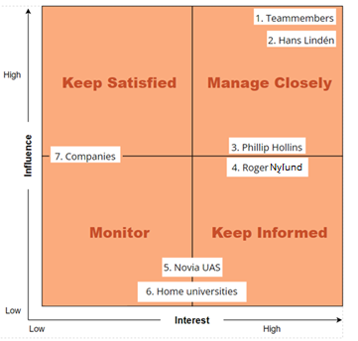

Figure 8 Stakeholders matrix where the stakeholders each have their own number

Established from Figure 8 can be that the group members and Hans Lindén have the most influence and interest in the project. The team members will take care of the project itself and the documentation. Hans Lindén is the supervisor and will provide all the help needed. Philip Hollins and Roger Nylund are placed in the middle of influence and a little bit on the higher side of the interest, because of the influence on the project’s time schedule and documentation. The universities don’t have influence on the project but have a small interest. Looking at the companies, a medium score is given on influence, when looking at the materials, but the interest is low.

### Risk management

All the project risks are marked in the risk register, Table 2. These risks are divided by internal and external project risks. The risks have an impact in the project, which can be prevented by the prevention-management. These risks are marked with the chance and the earnestness. This gives a threat score. The higher the score, the more impactful the risk can be. The highest scores are ranked in red, followed by orange and yellow.

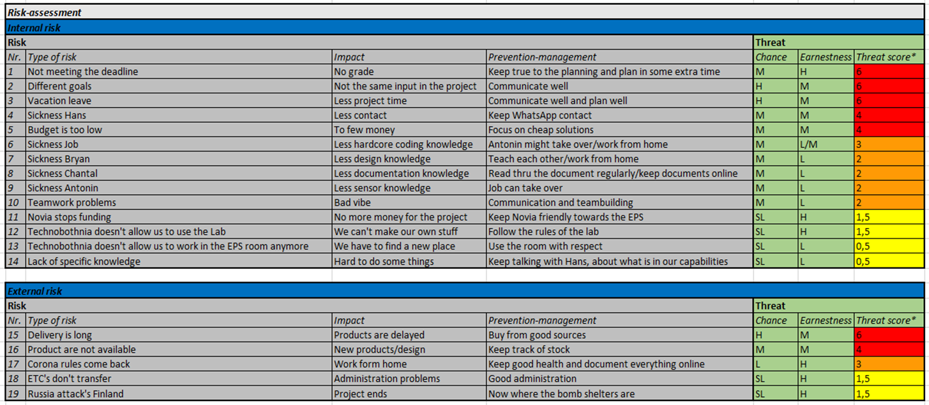

Table 2 Risk register with information about each individual risk

### Work breakdown structure

The Work Breakdown Structure (WBS) is a tool that breaks work into smaller task to make the work more manageable and approachable (WorkBreakdownStructure, 2022). There are two types of WBS: 1) Deliverable-based and 2) Phase-based. In this project the phase-based Work Breakdown Structure is mostly used and can be found in Figure 9.



Figure 9 Work Breakdown Structure (WBS) with the phase, each delivery and the tasks

### Gantt chart

The task list, Table 3, holds all the tasks in the project with the responsible persons, start date, deadline and completion. The tasks are divided into the phases of the project. These phases describe the intricate design phases and help the designer to come to a well-functioning product.

Table 3 List of tasks that needs to be done during the project

|  |  |  |  |  |  |  |  |
| --- | --- | --- | --- | --- | --- | --- | --- |
| **WBS** | **TASK** | **NAME** | **START** | **END** | **DAYS** | **% DONE** | **WORK DAYS** |
| **P1** | **Analyse phase & Idea phase** | | 12-9-2022 | 23-9-2022 | 12 | 100% | 10 |
| 1.1 | Meetings | All | 12-9-2022 | 12-9-2022 | 1 | 100% | 1 |
| 1.2 | Research | Bryan and Chantal | 12-9-2022 | 16-9-2022 | 5 | 100% | 5 |
| 1.3 | General code | Job and Antonin | 12-9-2022 | 16-9-2022 | 5 | 100% | 5 |
| 1.4 | Work document | All | 12-9-2022 | 13-9-2022 | 2 | 100% | 2 |
| 1.5 | Meetings | All | 21-9-2022 | 21-9-2022 | 1 | 100% | 1 |
| 1.6 | Design | Bryan and Job | 19-9-2022 | 23-9-2022 | 5 | 100% | 5 |
| 1.7 | Code | Job and Antonin | 19-9-2022 | 23-9-2022 | 5 | 100% | 5 |
| 1.8 | Documentation | Chantal | 19-9-2022 | 22-9-2022 | 4 | 100% | 4 |
| **P2** | **Concept phase** |  | 26-9-2022 | 16-10-2022 | 21 |  | 15 |
| 2.1 | Design | Bryan | 26-9-2022 | 7-10-2022 | 12 | 10% | 10 |
| 2.2 | Production | All | 23-9-2022 | 12-10-2022 | 20 | 40% | 14 |
| 2.3 | Code | Job and Antonin | 26-9-2022 | 10-10-2022 | 15 | 10% | 11 |
| 2.4 | Assembling | All | 10-10-2022 | 15-10-2022 | 6 | 0% | 5 |
| 2.5 | Meetings | All | 27-9-2022 | 27-9-2022 | 1 | 0% | 1 |
| **P3** | **Second concept phase** | |  | - |  |  | - |
| 3.1 | Research | All | 1-11-2022 | 4-11-2022 | 4 | 0% | 4 |
| 3.2 | Design | Bryan (all) | 1-11-2022 | 20-11-2022 | 20 | 0% | 14 |
| 3.3 | Code | Job and Antonin | 1-11-2022 | 15-11-2022 | 15 | 0% | 11 |
| 3.4 | Testing | All | 15-11-2022 | 16-11-2022 | 2 | 0% | 2 |
| 3.5 | Evaluation | All | 17-11-2022 | 18-11-2022 | 2 | 0% | 2 |
| **P4** | **Final phase** |  |  | - |  |  | - |
| 4.1 | Documentation | All | 12-9-2022 | 10-12-2022 | 90 | 30% | 65 |
| 4.2 | Prototype | All | 12-9-2022 | 10-12-2022 | 90 | 0% | 65 |
| 4.3 | Presentation | All | 12-12-2022 | 14-12-2022 | 3 | 0% | 3 |
| 4.4 | Poster | All | 20-11-2022 | 21-11-2022 | 2 | 0% | 1 |

The Gantt gives an overview of the tasks within the timeline of the project. The start and end day of each task can be seen in Table 4.

Table 4 Overview of all the task for the project with the responsible people and the deadline



# 

# Analyse phase V1

In this chapter the first phase, analyse phase, for the first version of the weather station is described. It contains the problem statement, the first question, the answers on the first question and the design of the logo.

## Problem statement

### What?

In this project the goal is to build a low-cost IoT weather station at Novia UAS that is solar powered and has wireless data transfer to MQTT broker. Besides that, minimal power should be consumed. Firstly, a working system, prototype, should be made using commercial sensors. The network LTE-M can be used first, but later NB-IoT will be used for more energy efficiency. Furthermore, low-cost sensors should be assessed and with the help of additive manufacturing other sensors the overall cost should be lowered. The code must be made modular so that additional sensors can easily be added and is easy to use.

### When?

The duration of the given project will be from the start of September till the middle of December. The midterm presentation will be held at the end of October. For this presentation a prototype should be finished and most information should be gathered. In the middle of December, the final presentation will be held. It should include the final report, the final version of the weather station and all the other relevant information.

### Who?

The people who will work on the project are Antonin Silvestre, Bryan Arents, Chantal Tijhuis and Job van Koeveringe. The group will be supervised by Hans Lindén. For questions about the European Semester Project Roger Nylund can be approached. Furthermore, the information gathered is for the sake of the school, Novia UAS, and especially for the one leading the project, Hans Lindén.

## Questions and actions

### 2.2.1 General

1. Where should the weather station be mounded?
   * Field measurements
2. What kinds of production equipment is available?
   * Hans guided tour
3. Which professional examples are already available?
   * Desk research
4. Which amateur examples are already available?
   * Desk research
5. How to present the data?
   * Brainstorming
6. How to advertise our project?
   * Brainstorming
7. What will be the logo?
   * Design
8. What is the future vision?
   * Brainstorming

### 2.2.2 Sensor

1. What kinds of sensors will we be mounting on version 1?
   * Hans
2. How to connect all the sensors?
   * Electronic research
3. What voltage do the sensors work on?
   * Electronic research

### 2.2.3 Programming

1. What kind of library’s do we need to use?
   * Programming research
2. What is NB-IoT?
   * Desk research

### 2.2.4 Design

1. How to protect the electronics against the outdoor environment?
   * Desk research and design
2. How to mount the weather station?
   * Desk research, sketching and modelling
3. How to make the station modular interchangeable?
   * Sketching and modelling

## Answers

### 2.3.1 General

#### Where should the weather station be mounded?

The first version of the weather station will be mounted on the top of Technobothnia. There are several options to mount the device. The first option is to mount the device on a lightning distractor tower. This will give a strong and stable mounting point. Figure 10 shows the mounting points with the dimensions of the lightning distractor tower on top of Technobothnia.

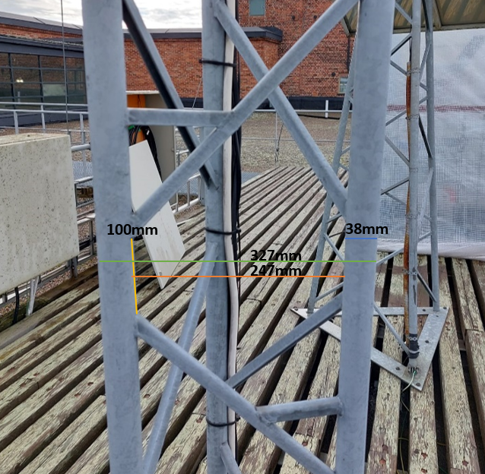  
The pros of this mounting spot would be a level and sturdy mounting place. This mounting place has some cons. For example: The inability to easily move the weather station from Technobothnia to the Novia building. There is also a chance that the mounting spot has different dimensions on the Novia building. This would mean there is a possibility that the second version would have to be a total new design.

Figure 10 Dimensions mounting point

The other options are to design a new mounting area. This may solve the cons, but it would mean a little bit more work. Fortunately, there is a lot of time for this project. This will be further investigated in the idea phase.

#### What kinds of production equipment is available?

A lot of equipment is available. The things that are not available are the 3D metal printer, the CNC machine and the robot arms. The other equipment located in Technobothnia are accessible. The materials to work with are wood, plastic and metals. A broad selection of design options is available. The best way to approach choosing the production process is to first look at what is the best for outdoor use. A professional look is wanted as well.

Most of the parts will be 3D-printed, because that is a good option to make intricate designs cheaply. Also, some metal work can come in handy to make sturdy bases.

#### Which professional examples are already available?

Figure 11 shows the searched professional examples of weather stations. It can be seen that most of them are built in similar ways, like SparkFun Electronics (1), Sectron (2) and Weatherspares (4). The one from Meter (3) looks more compact.

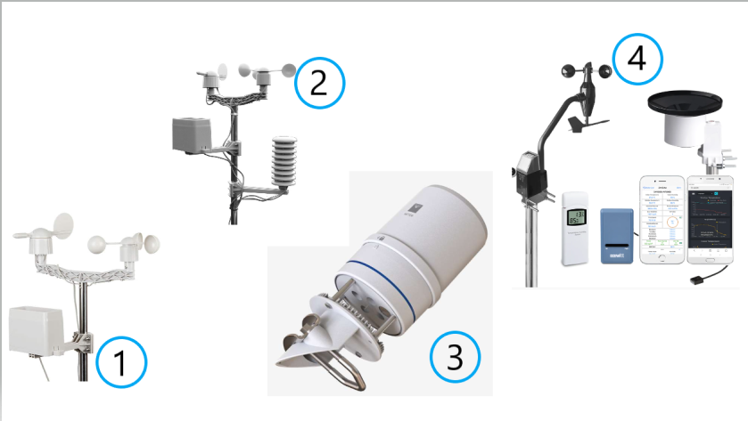

Figure 11 Display of professional weather stations

Table 5 Professional examples of weather stationsTable 5 shows some extra information about the different professional-made weather station. Information about the used materials and the things measured can be found.

Table 5 Professional examples of weather stations

|  |  |  |  |  |
| --- | --- | --- | --- | --- |
| Nr. | ManufactureR | Sensors and materials | Measured | Source |
| 1 | SparkFun Electronics | wind vane, cup anemometer, tipping bucket rain gauge, two-part mounting mast, rain gauge mounting arm, wind meter mounting bar, mounting clamps and zip ties | wind speed, wind direction and rainfall | (SparkFun Electronics, 2022) |
| 2 | Sectron | touch LCD with backlight, API, base station (receiver), wind direction sensor, wind speed sensor, rain gauge, USB cable and PC software | barometric pressure, outside temperature, indoor temperature, external and internal relative humidity, wind speed and amount of precipitation | (SECTRON, 2020) |
| 3 | Meter | pyranometer spectral response compliance, GSA, solar radiation, precipitation, humidity sensor temperature, vapor pressure, barometric pressure, horizontal wind speed, wind gust, wind direction, tilt, lightning strike count, lightning average distance, output, data logger compatibility, connector types, stereo plug connector and conductor gauge | air temperature, relative humility, vapor pressure, barometric pressure, wind speed, gust and direction, solar radiation, precipitation, lightning strike counter and distance | (Metergroup, 2020) |
| 4 | Weatherspares | WH57 lightning sensor, WH45 PM2.5/PM10/CO2/temperature and humidity all-in-1 sensor, WH31 multi-channel temperature and humidity sensors, WH51 soil moisture sensors, WH41/WH43 PM2.5 air quality sensors, WH55 water leak sensors and WN34 temp sensors | anemometer, solar radiation, UV level, light intensity, temperature, humidity, rain, rainfall, windchew, dew point and heat index | (Weatherspares, 2021) |

#### Which amateur examples are already available?

Figure 12 shows the searched amateur examples of weather stations. These are some of the hand-made examples in DIY-form. The weather station made by S. Agrawal (4) is based on IoT and the one from Open Green Factory (2) is solar based. Those can be useful for this project. Some of the pictures only show the sensor set-up as the end product, those are from C. Barnatt (3) and S. Agrawal (4). U. Winberg (1) has made a design that looks similar to the one of Open Green Factory.

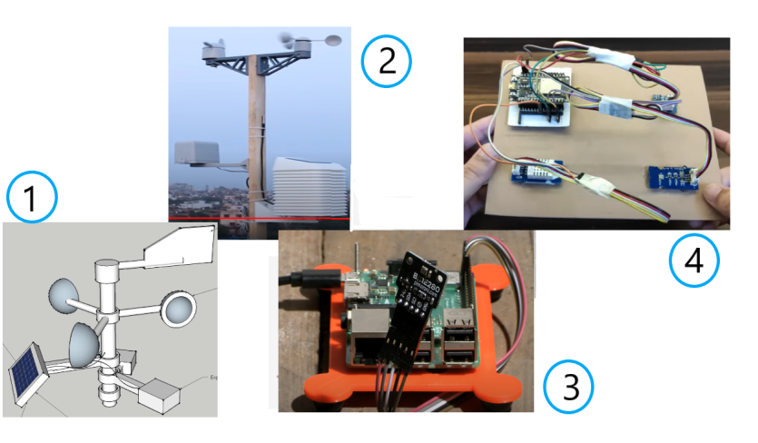

Figure 12 Display of amateur weather stations

Table 6 shows some extra information about the different professional-made weather station. Information about the used materials and the things measured can be found. Only a few home-made examples are listed in the table. More can be found in B. Appendices.

Table 6 Amateur examples of weather stations

|  |  |  |  |  |
| --- | --- | --- | --- | --- |
| Nr. | Manufacturer | Sensors and materials | Measured | Source |
| 1 | Ulf Winberg | push switch, voltage regulator XC6217, resistor 1k;2k;4k;6k, header pin, hall sensor, Bluetooth LE transceiver, Blue low energy device with programmable microcontroller, super capacitor 5F, solar cell, antenna, resistor 1M, capacitor 1u, resistor 2M;100hm;10k;150;300, header pin 2x1;2x10;2x3, CPC102N, CPC1117N, shottky diode CU5520 H3F and temp sensor LM94022 | temperature, wind and sun | (Winberg, 2015) |
| 2 | Open Green Factory | ESP32 Dev Kit V1, TP4056, barometric pressure sensor BME280, temperature sensor - DS18B20, UV index sensor - GY1145, lux level sensor - BH1750, wind & rain sensor, MCP1700-3.3V, resistors - 2 x 1K, 1 x 10K, 3 x 4.7K, 1 x 27K, 1 x 100K, electrolytic capacitor - 1 x 100uF, ceramic capacitors - 4 x 0.1uF, TVS Diode - DT1042-04SO, RJ11 connector, male / female headers, jumper cap, screw terminal-2P - 5.08mm pitch, screw terminal -3P -3.5mm pitch, solar panel - 5V / 1.2Watt, 18650 battery, 8650 battery holder, 22 AWG wires and slide switch | internal temperature, humidity, barometric pressure, external temperature, wind speed, wind direction, rain gauge, UV-index and lux level | (Open Green Energy, 2021) |
| 3 | Christopher Barnatt | Bosch BME280 temperature, pressure, humidity sensor, I2C interface, Qwiic/STEMMA QT connector  3.3V or 5V compatible, reverse polarity protection, Raspberry Pi-compatible pinout,  compatible with Arduino, compatible with Raspberry Pi and compatible with Raspberry Pi Pico | temperature, pressure and humidity data | (Barnatt, 2021) |
| 4 | Saiyam Agrawal | ESP32 development board, DHT11/21/22 temperature & humidity sensor, SI1145 sunlight sensor, BMP180 barometric pressure sensor, perfboard or breadboard,  male to female jumper wires, grove connector cables and micro-USB cable | temperature, humidity, barometric pressure  UV index  IR radiation  visible light | (Agrawal, 2022) |

#### How to present the data?

The best way to present data is via a website or a mobile app. This will be quickly accessible and not too hard to realise. The data should be in numbers or in letters, but also visible by icons or for example a chart.

#### How to advertise the project?

There are diverse ways to advertise the project. There is at least a requirement to make a poster in A4 format. Furthermore, a website is also an effective way to promote the project and at the same time present the data. There is a screen in Technobothnia where the data can be shown. This would also advertise the project, by putting in a link and the logo.

#### What will be the logo?

The logo should include the name of the project team and some visual representation. The logo should be easily 3D printable and it should have a professional outlook.

#### What is our future vision?

In the future vision the team will describe what is important for them to focus on during this project.

### 2.3.2 Sensor

#### What kinds of sensors will we be mounting on version 1?

The sensors that will be mounted:

* Temperature sensor
  + Temperature sensor FS 400-SHTXX
  + *Industrial Dustproof Temperature Sensor Stainless Steel Plastic Housing I2C Output FS400-SHT3X*. (z.d.). AliExpress. Checked on 14 September 2022 of <https://www.aliexpress.com/item/4000117617368.html>
* Wind speed + direction sensor
  + Davis vantage pro Anemometer
  + *Davis Vantage Pro2 Anemometer 6410*. (2021, 22 June). Weather Spares. Checked on 14 September 2022 of <https://weatherspares.co.uk/products/davis-vantage-pro2-anemometer-6410?variant=20218104447072&currency=GBP&utm_medium=product_sync&utm_source=google&utm_content=sag_organic&utm_campaign=sag_organic&utm_campaign=gs-2021-06-22&utm_source=google&utm_medium=smart_campaign&gclid=Cj0KCQjw94WZBhDtARIsAKxWG-_QSGN0U5Ch_GhEsf1bbqBpcDJ_5Tzjpli3pTBgN5dYSE2nTW7a0VwaAnHnEALw_wcB>
* Rainfall sensor
  + Davis AeroCone® Rain Collector W/Vantage Pro2™ Mounting Base
  + Khunt, S. (2022, 20 September). *Davis AeroCone® Rain Collector w/Vantage Pro2TM Mounting Base*. Stock4less EU. Checked on 14 September 2022 of <https://stock4less.eu/en-fi/products/6466-dav?variant=43158546940140&utm_medium=cpc&utm_source=google&utm_campaign=Google+Shopping&gclid=Cj0KCQjw94WZBhDtARIsAKxWG-87uEPYkIM08thNow4o6E_VQ9Tb79KHh_kfQJ-wlfJvFXV9FmnGSOIaAg1VEALw_wcB>

#### How to connect all the sensors?

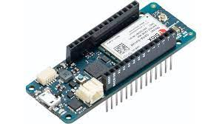

Figure 13 Display of an Arduino MKR NB 1500

The sensors will be connected to the Arduino via male cables. The Arduino used is the MKR NB 1500, see Figure 13. This Arduino allows communication over NB-IoT and LTE-M networks. Communication over these networks will make the weather station excellent for working in remote areas. The connection cable for the sensors still must be bought.

In addition, the following image, Figure 14, shows the pinout diagram to get a better idea of the functionalities of this board.

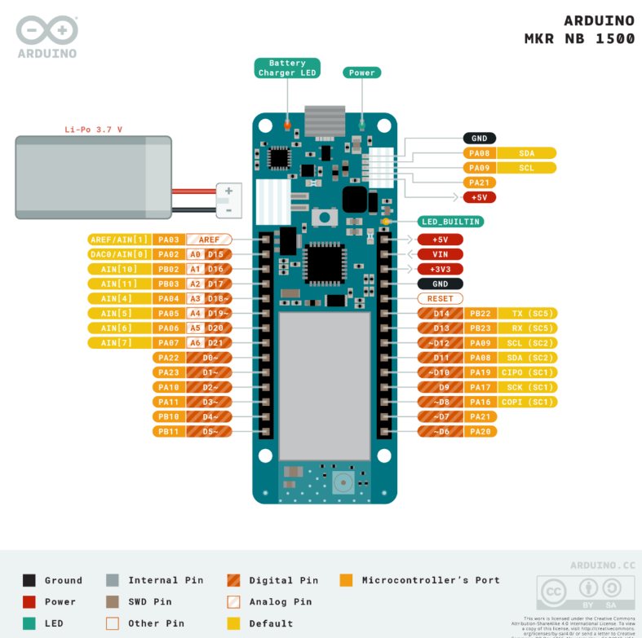

Figure 14 Closer look on the function of the Arduino with information about each pin

This Arduino is perfectly compatible with our goals. All these features make the Arduino MKR NB 1500 board an excellent for many of the basic IoT application scenarios. It is a smart choice for any beginner, maker or professional to get started with Internet of Things (IoT). Its wireless connectivity ability makes this board suitable for use in projects that will communicate with the cloud, such as collecting data from the sensors and uploading this data to cloud services.

#### What voltage do the sensors work on?

The sensors should work on the Arduino outputs voltage of 3.3V or 5V.

### 2.3.3 Programming

#### What kind of libraries do we need to use?

As an example, for the Arduino the library C++ is used. C++ comes in two pieces: A header file that defines the functionality the library is exposing (offering) to the programs using it and a precompiled binary that contains the implementation of that functionality pre-compiled into machine language (Alex, 2022).

#### What is NB-IoT?

NB-IoT stands for Narrowband Internet of Things protocol using low-power wide area network technology. It is a new technology the enables a wide communication range. This enables the weather station to be used everywhere, wherever there is a mobile network connection.

### 2.3.4 Design

#### How to protect the electronics against the outdoor environment?

It is best to choose sensors that are weatherproof, so the weather station can be placed outdoors in all-weather circumstances. The provided sensors are all weatherproof. The Arduino and the connectors are the only things that are needed to be placed inside a waterproof box. The antenna should also be waterproofed. This can be done by using a waterproof kit around the opening of the box for the antenna.

#### How to mount the weather station?

The weather station will be mounted on a moveable station. This will have some tripod feet to stabilize the thing. In the idea phase, more attention will be paid on the mounting station.

#### How to make the station modular interchangeable?

The easiest way to make the station modular interchangeable is to make a mounting station that has a long pole where the sensors can be mounted on. There should be some system to secure and remove the sensors. For example, a hook or a clamp. This will be further investigated during the idea phase.

## Logo

The logo is found in Figure 15. The logo is designed to give attention to the group name, which is ‘Weathercrew’. The name ‘Weathercrew’ came in mind, because the team is a crew that works on measuring different weather. The logo has a visual attention getter for the things that are important in this project. The visuals stand for the weather that gets measured by the weather station. All the symbols are connected, this is a reference to the weather station being wireless connected to the mobile networks. The colours are all in black, so it will give off a professional look. The logo is surrounded by a rectangle, which brings it all together.

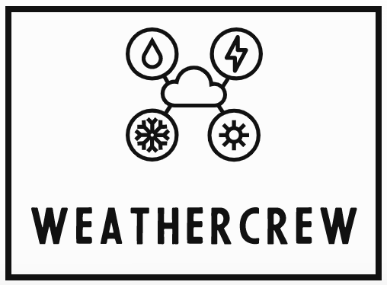

Figure 15 Display of the group’s logo

## Future vision

Our aim is to design a low-cost weather station that will endure for the upcoming years. It will work with renewable energy so it will also be environmentally friendly.

# Idea phase V1

The chapter ‘Idea phase V1’ will contain the first sketches, ideas and designs for the first version of the weather station. It gives information about the mounting station, the material that will be used, the housing for the sensors and which additive manufacturing material is best to use.

## 3.1 Problems

### 3.1.1 General lay-out

First thing to figure out is the general lay-out of the weather station. For example, how are the modules going to be mounted and what is on the weather station. In Figure 16 is a sketch of how the general lay-out should look like. Thought has been given on the weight balance and the guideline height standards. The height standards are important for accurate measurement readings. The rain sensor is mounted 200mm sideways form the main pole.

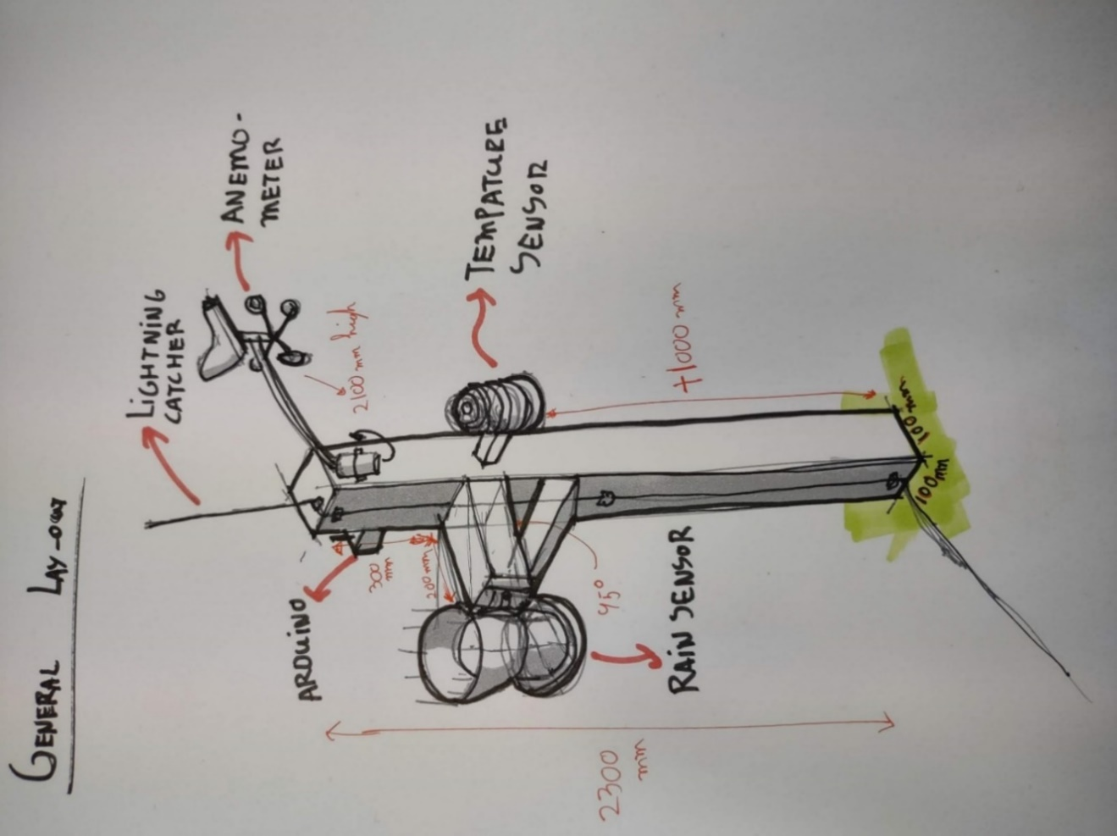

Figure 16 General lay out sketch

### 3.1.2 mounting station

The design of the mounting station is also required. In the next figure, Figure 17Figure 17, there are some sketches of possible mounting stations. The best ones are worked up with more detailed sketching. Design one has the most advantages, such as that it is a stable structure. This will be the first suggestion to make. Design two is the quick fix, if design two doesn’t work like it should.

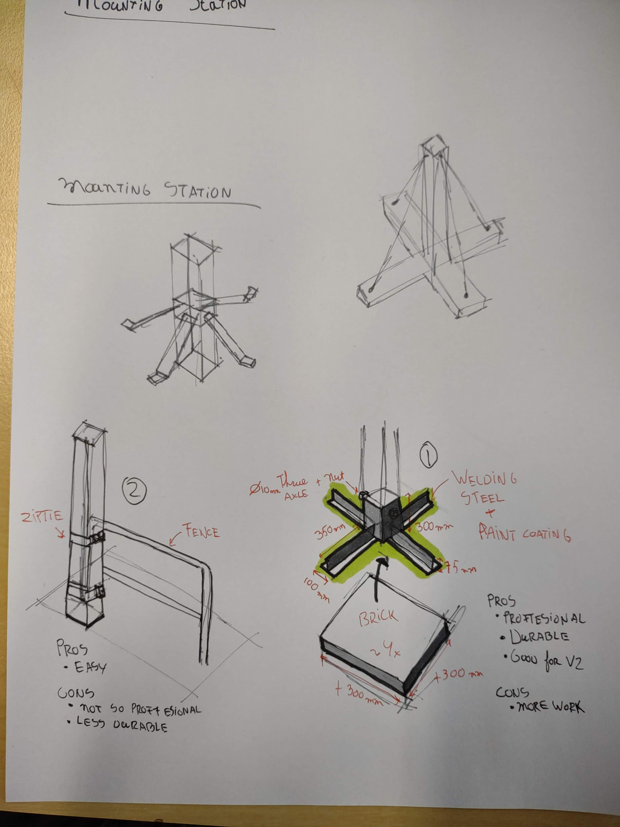

Figure 17 Mounting station designs

### 3.1.3 Interchangeable

By choosing a wooden post for mounting the modulus are easily interchangeable by screwing or unscrewing the modulus. This solution is fine for the first version and might also be a workable solution for version 2.

### 3.1.4 Housing

A weatherproof housing is required to keep the Arduino battery and the antenna safe. In Figure 18 it is shown how the housing for the sensors is designed. 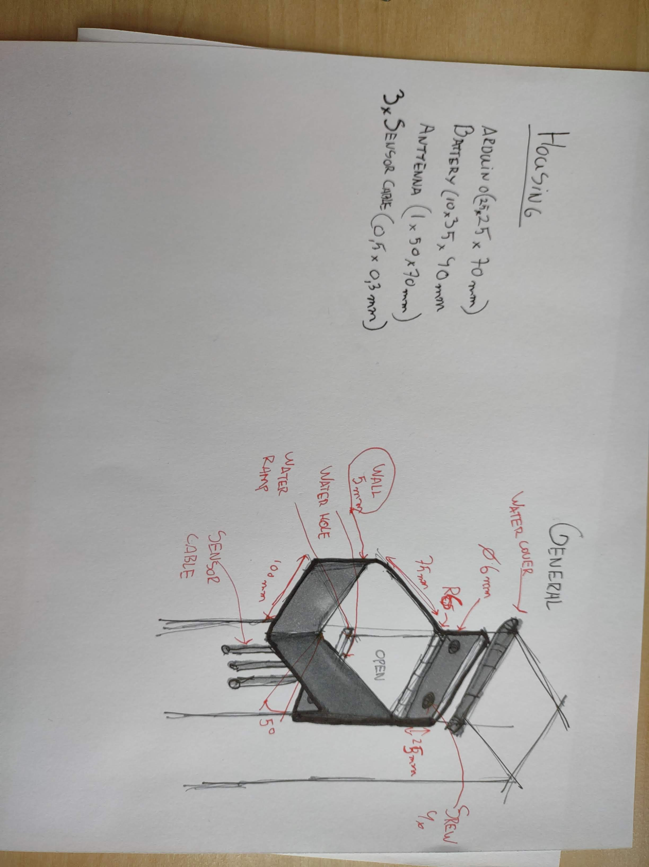

Figure 18 Housing for the sensors

### 3.1.5 Sun protection temperature sensor

The temperature sensor is sensitive to temperature. If the sun hits the sensor, the temperature will spike. This is not favourable for the measurements of the air temperature. A sun protector is needed, that also has free flow of air.

## 3.2 Material choice

### 3.2.1 Mounting station

The mounting station will be the structure that will support the housing for the sensors. Furthermore, it is a structure to mount the rest of the sensors. Extra information about the durability of the materials is given in B. Appendices.

#### Parru PROF solid wood green 100x100 NTR/A3.2.1.1 Pole

Figure 19 Wood used

The pole will be made of Parru PROF wood that is 100x100mm. The wood is used to support structures that are in contact with earth, water and concrete. It is sustainable, which means that it’s versatile for yard and environmental construction (K-Rauta, 2022). The size of the wooden pole is chosen to be a bit smaller than the designed housing for some extra leeway. *The chosen shape is a square, instead of a circle, because more surface area can be used for the housing and the mounting. Moreover, it is easier to find wooden poles in square shape.*

#### Afbeelding met bouwmateriaal, baksteen, timmerhout, steen Automatisch gegenereerde beschrijving3.2.1.2 Base

For the base Concrete slab grey BL305 300x300x50 offer Varnish (Hartman, 2022). *This concrete may support the pole to stand up straight, because of their weight.* The squares will be put on every side of the pole structure to make an even distribution of weight. To secure the concrete slabs in place, L-shaped steel will be used. This can be seen in Figure 17.

Figure 20 Concrete used

#### Post leg PROF hot-dip galvanized 102x102mm3.2.1.3 Assemble point

Figure 21 Steel used

A PROF post leg is used to secure the pole and the concrete together (K-Rauta, 2022). The size is 102x102mm and fits the wooden pole perfectly. *It will make the structure stronger and better resistant to the wind.*

### 3.2.2 Additive manufacturing

For additive manufacturing different plastic and materials can be used. A closer look will be given on Polylactic Acid (PLA), Acrylonitrile Butadiene Styrene (ABS), Polyethylene Terephthalate   
Glycol (PETG) and Acrylonitrile Styrene Acrylate (ASA). Table 7 shows the advantages and disadvantages of each material on key features (Flynt, 2020).

Table 7 Additive manufacturing filament and their advantages

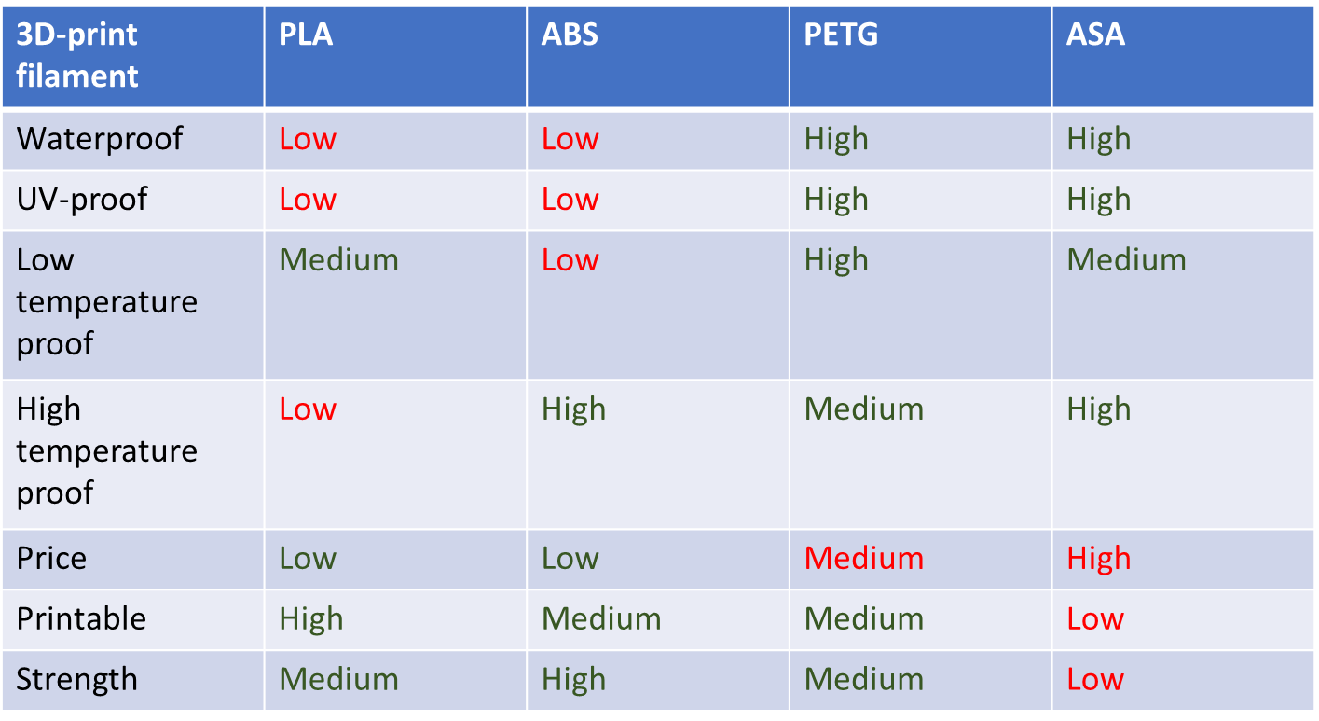

For the first few designs and prototypes PLA will be used. As seen in Table 7 it is low in price and it is easy to print, which shortens the time of the print. Eventually, for the final version of the weather station it is better to use PETG. The weather station will be places outside and needs to be as weatherproof as possible. PETG scores high on waterproof, UV-proof. Furthermore, it can endure at low temperatures. PETG is a bit more expensive than PLA, but the functionality compensates it.

# 4. Concept phase V1

In the concept phase the first version concept will be displayed and explained. A closer look is given on the coding and all the designed and printed parts will be explained.

## 4.1 Design

### 4.1.1 Marketing

#### 4.1.1.1 Display of logo

To display the responsible project team, the logo has been put on the top of the weather station with a little house to pull some extra attention. The final design is also made with dual 3D-printing to add different colors for even more pull towards the logo, seen in Figure 22.

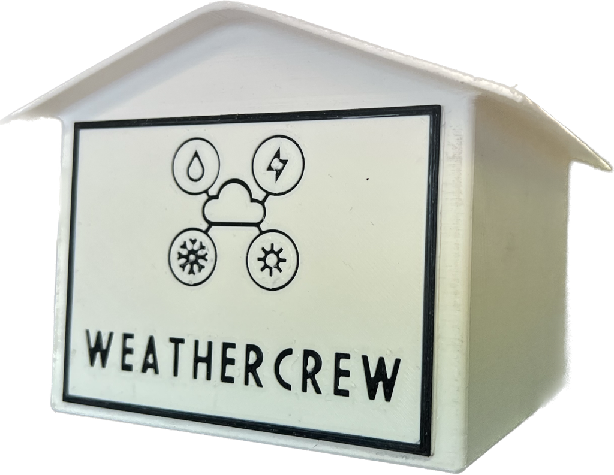

Figure Marketing house

#### Poster

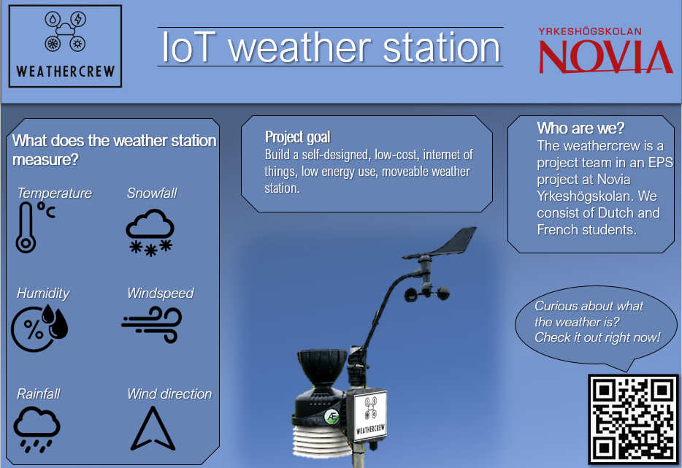A poster is made to show the project to the other students and teachers. In Figure 23 the first version of the poster can be seen. The QR-code to the website works.

Figure 23 shows the first poster that has been made for marketing

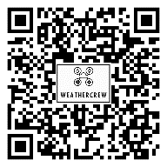

### General design

The general design is to be found in Figure 24. The mounting pole is fabricated by woodworking. The sensors are placed with the requirements of the sensors. For example, the windspeed/direction sensor is placed at 2100mm and does not have any wind obstructions. The rainfall sensor is placed 300mm to the side, so there is no obstruction of rain. The Arduino housing is placed at a place that is easy to reach, so this helps with maintainability. The temperature sensor is also easily reachable, because there is not a height requirement.



Windspeed/direction sensor

Marketing house

Rainfall sensor

Rainfall sensor extension

Arduino housing

Temperature sensor

Left over cables (Not allowed to shorten)

Wood base 100x100mm

Figure 24 General design

### Mounting base

The mounting base is important, because if it fails it could break all the sensors. Therefore, the mounting base is built out of metal, because it is stronger than wood and has more weight. The mounting base is fabricated with a garden pole mount and 4x 300mm steel L-beams. These L-beams are for stability and to put extra weight in the form of garden tiles. This keeps the weather station on the ground.

It is built by sawing the l-beam into four pieces. Then it’s grinded down and cleaned up. This made it possible to weld the pieces together. After the welding, the entire thing is leveled out by force. After that, it was time to sandblast the entire thing to make it ready for painting. The painting is done in black, because it fits the theme of the weather station very well. In Figure 25 the technical work drawing is to be seen. This was used to fabricate the mounting station.

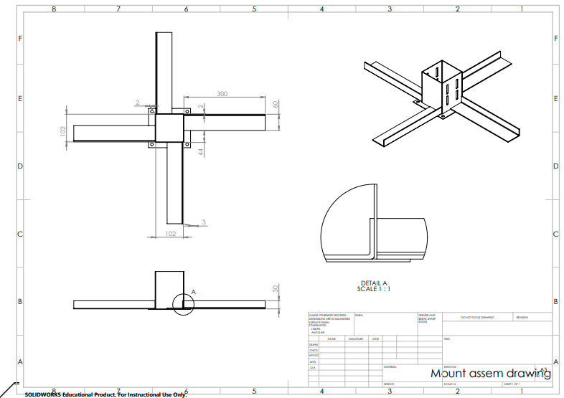

Figure 25 Mounting base drawing

The fabricated piece looks like Figure 26.

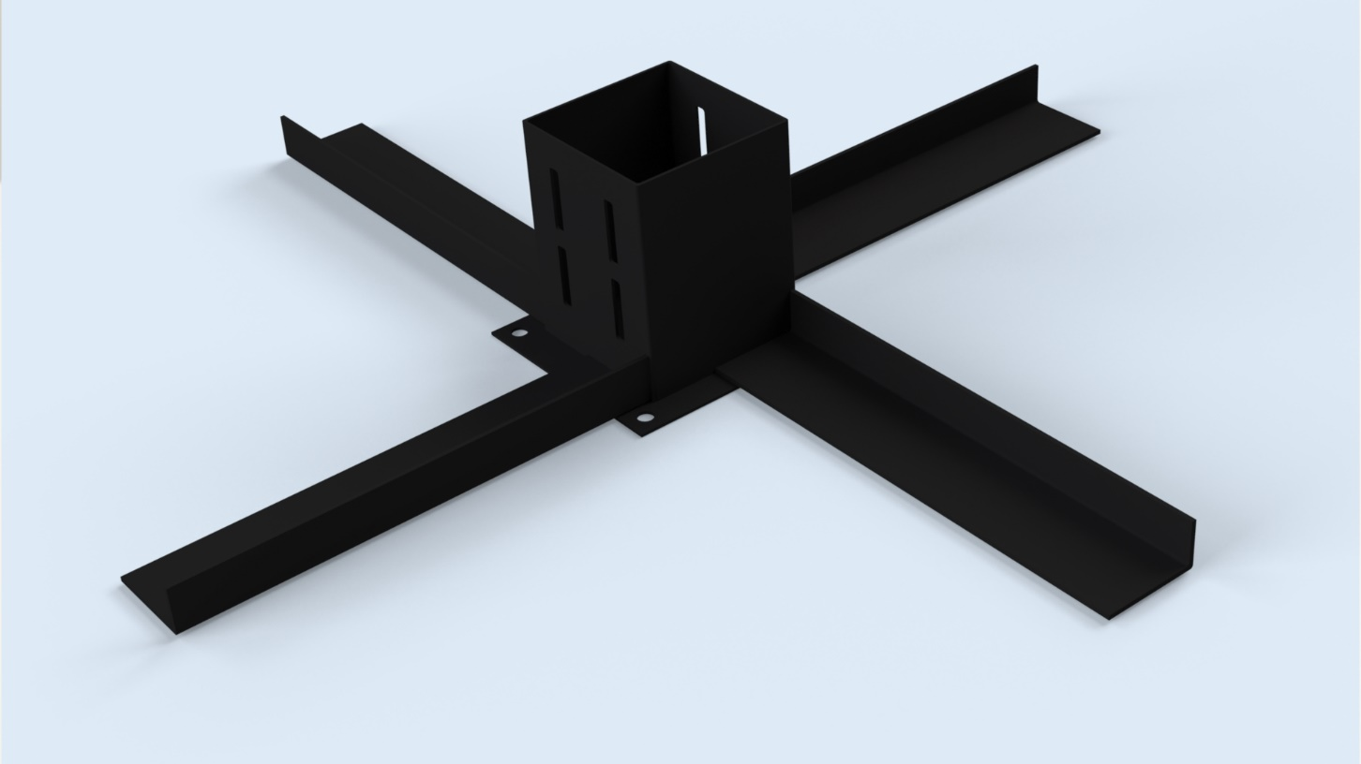

Figure 26 Mounting base

### Arduino housing

#### 4.1.4.1 Version 1

The Arduino housing is to keep the Arduino, connectors, antenna and battery far away from the elements. This is done by mounting the housing directly to the wooden pole with a rubber seal in between. Any condense that still could come in rolls down to the cable opening, because there is a 5-degree slope on the design. After discussion, it was decided not to use this design, because it would mean the hole housing had to be unscrewed to access the Arduino. In the next the design the top should be easily removable. The first version is to be seen in Figure 27.

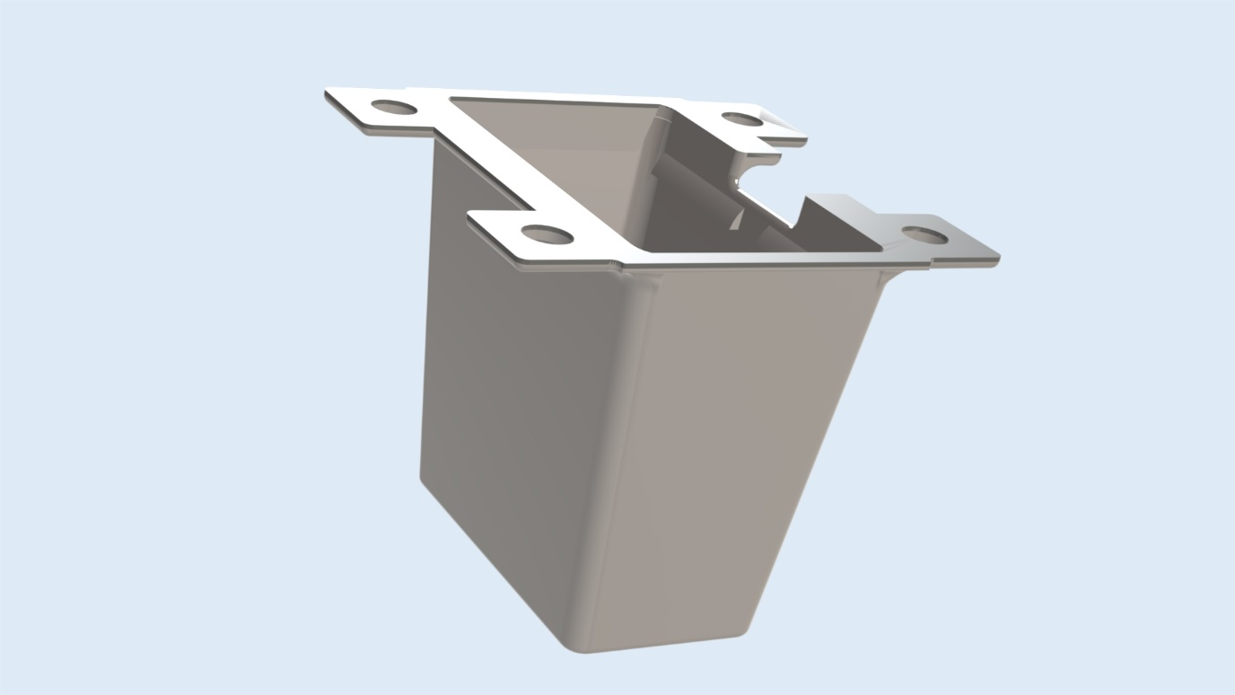

Screw holes 4x

Opening for the components

Blockage for stopping the components from sliding out

Opening cables

5-degree angle

Figure 27 V1 Arduino housing

#### 4.1.4.2 Version 2

The second version should have a removable top to access the components. The version 2 is 3D-printed with ASA filament. There are some extra improvements to the housing, such as a thinner wall as a place for the antenna. The top is to be found in Figure 28 and the bottom is to be found in Figure 29.

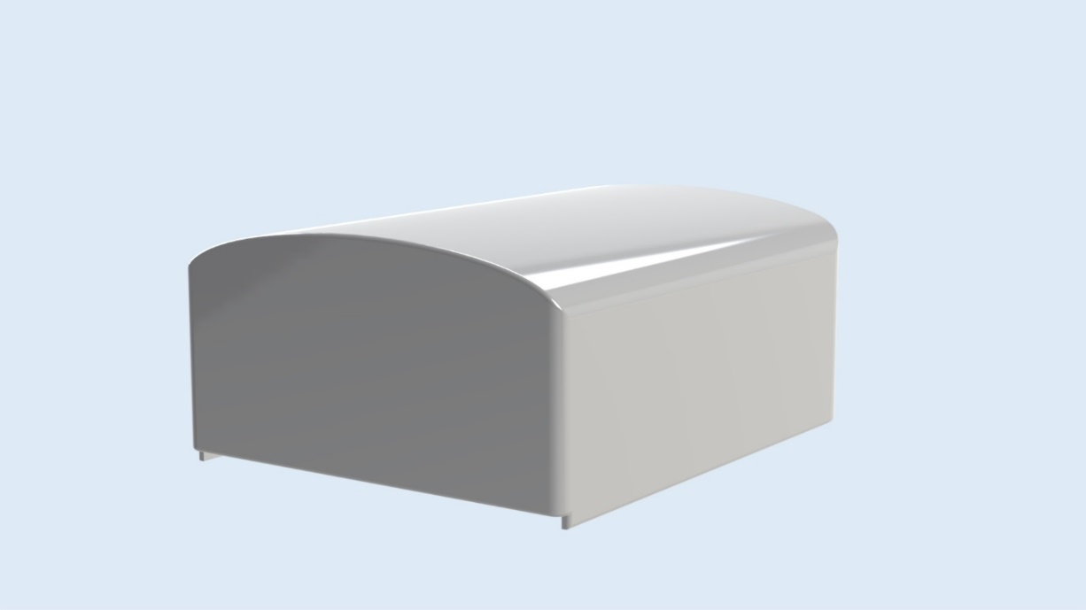

Figure 28 V2 Top Arduino housing

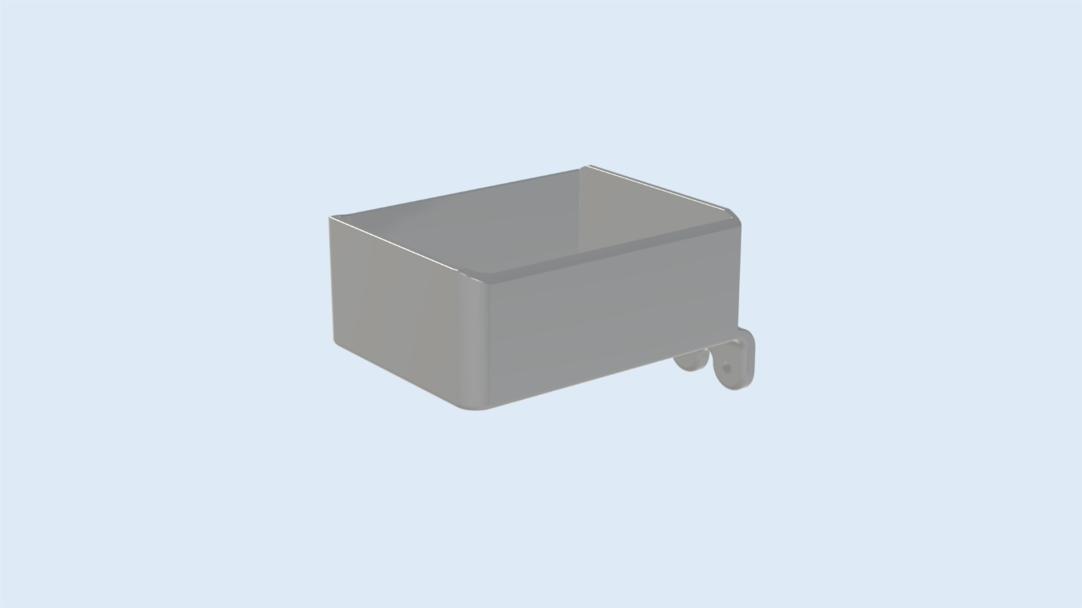

Figure 29 V2 Arduino housing

In Figure 30 the design of the inside of the Arduino housing is explained. All the components are lifted, so condense will not touch the components.

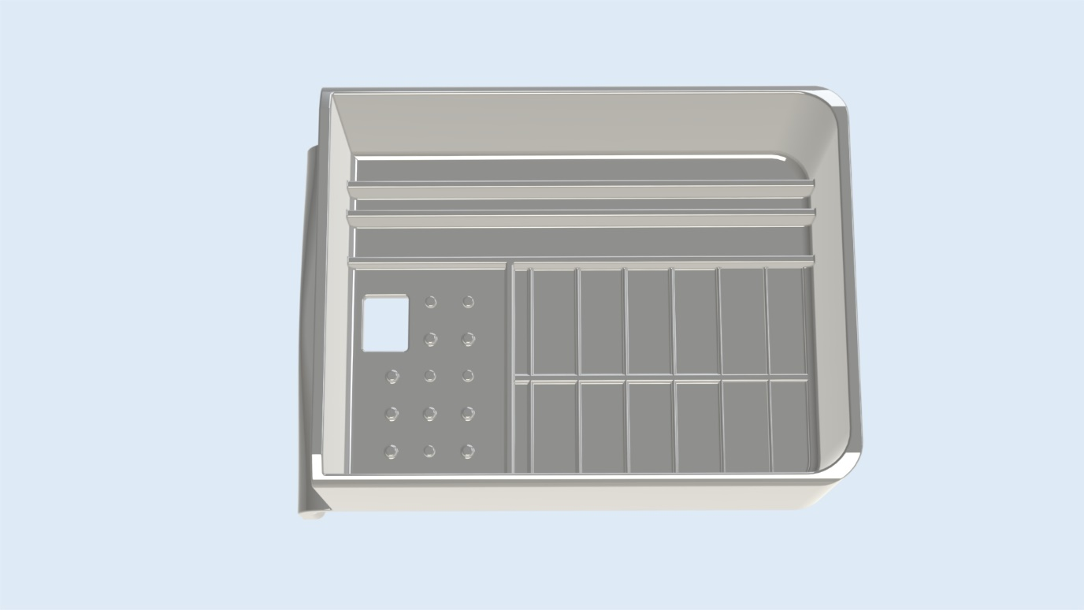

Screw holes Cable opening Battery place Antenna place (thin wall) Arduino rails

Figure 30 V2 Arduino housing

### 4.1.3 temprature sensor housing

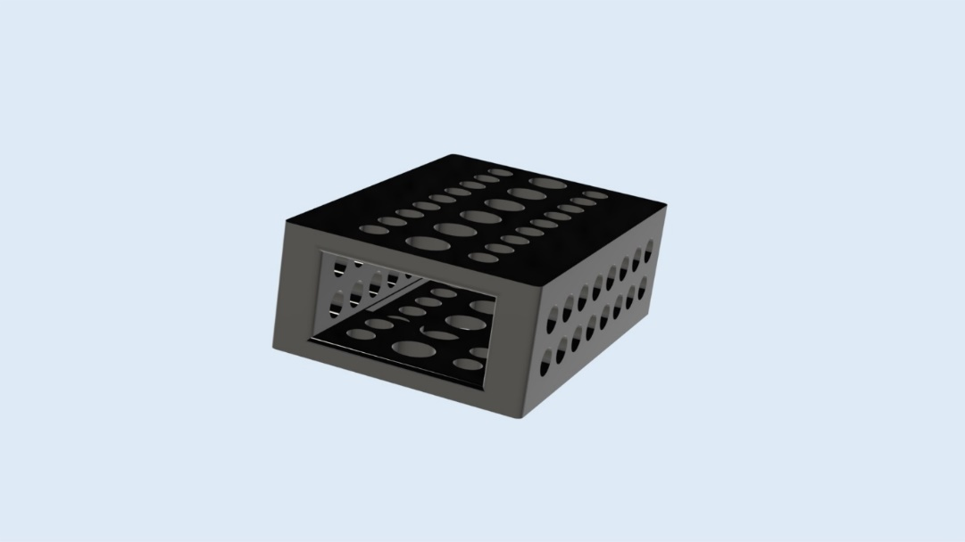

Figure 31 Temperature sensor component

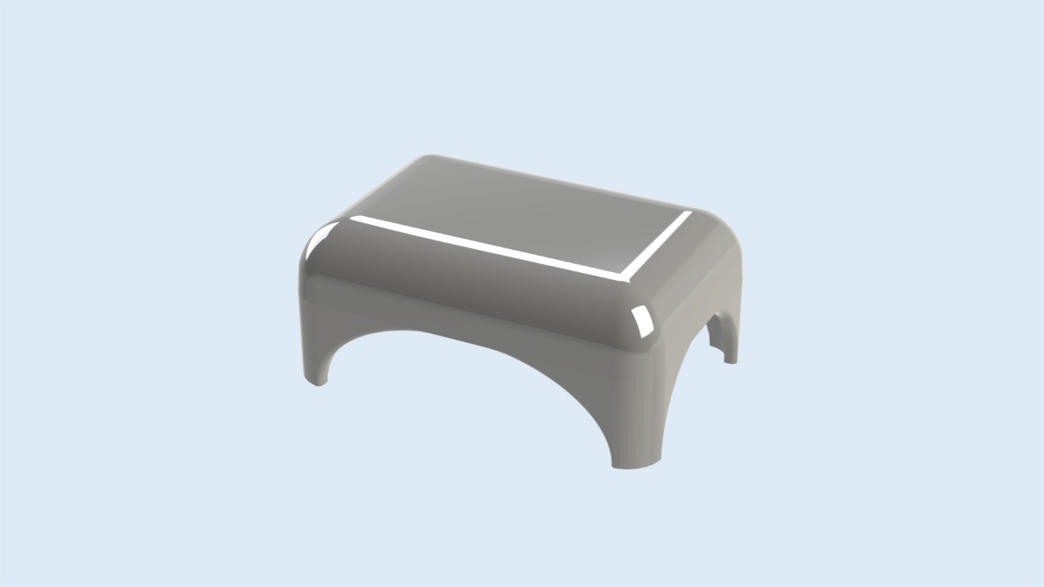The sensor that will be used for the temperature and humidity is small and not weatherproof. This means that it should be protected against the elements, but there should also be free airflow to the sensor for it to be accurate. This makes it a little hard. Therefore, the sensors are first placed inside the component from **Error! Reference source not found.**. This has many holes so there is free airflow and it can be mounted to the top of the housing design from **Error! Reference source not found.**. The top of the housing design also has airflow openings. This product is glued to the bottom housing. This part of the housing also has some openings, but these are for letting out any snow/rain inside of the housing. The bottom part of the housing is used to mount the entire product to the pole.

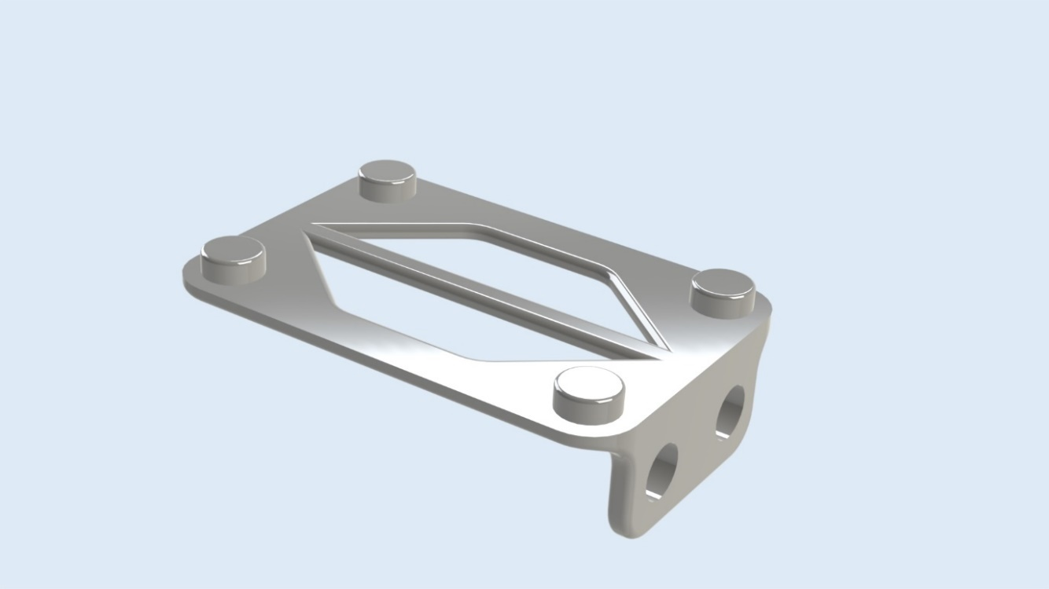

Figure 32 Temperature housing top and bottom

## 4.2 Code

### 4.2.1 Wind speed

Register WindSensorSpeedPin and attach interrupt:



Add one rotation when there is a full rotation:

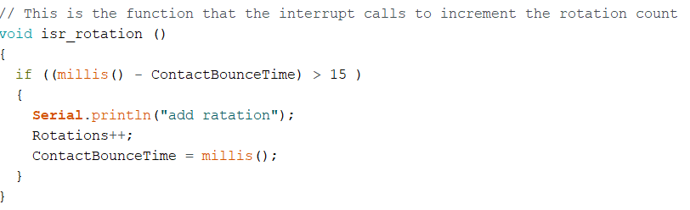

Calaculate wind speed for Miles and Kilometer per hour:

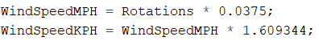

Reset rotations after calculating speed:



### 4.2.2 Wind direction

Reads analog data with a value from 0 to 1023 and converts it to rang of 0 to 360.  
If the wind direction has an offset, it will be added.

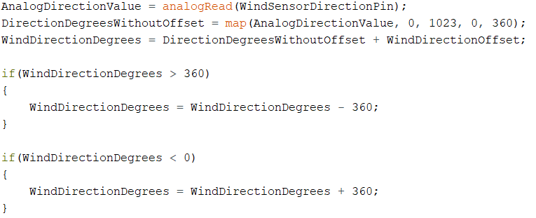

### 4.2.3 Rainfall

Register RainSensorPin and attach interrupt:



Add bucket amount to hourly and daily rain value when the bucket tips:

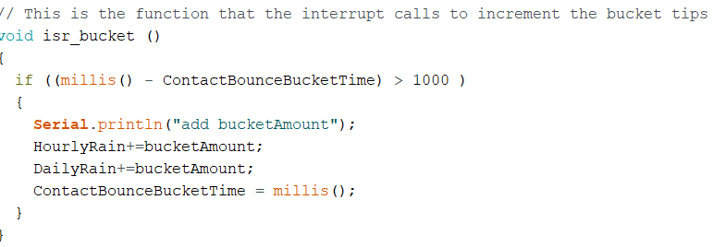

Reset the hourly and daily rain value:

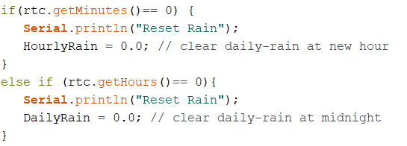

### 4.2.4 Temprature and humidity

Reads digital data by protocol I2C from the AM2320 sensor.

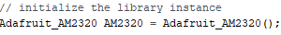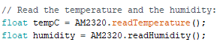

### 4.2.5 Battery

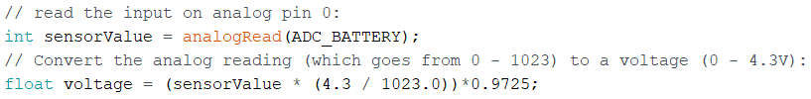

### 4.2.6 Setup

Start Serial port:

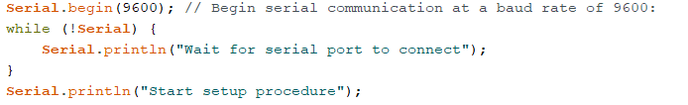

Set date and time for the Arduino:

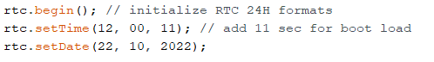

Connect to Internet:

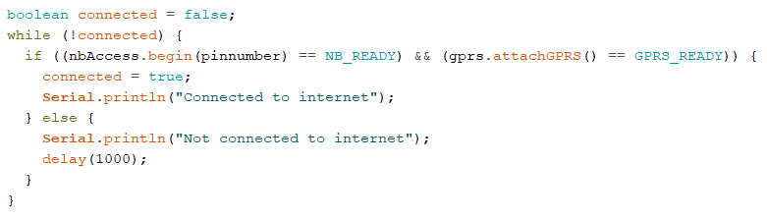

Connect to MQTT:

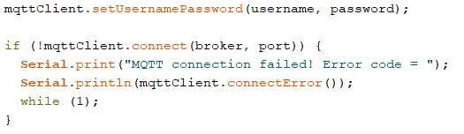

### 4.2.7 Color cables

The cables assemblies are made easy and maintainable by using different colors for different functions.

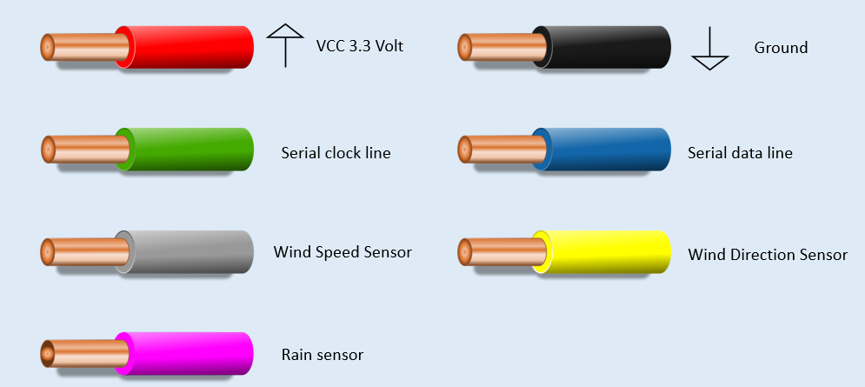

Figure 33 Color cables

# A. References

Agrawal, S. (2022, Januari 21). *ESP32 Based IoT Weather Station | How To Make | Complete Guide*. Retrieved from YouTube: https://www.youtube.com/watch?v=GE5an3kYOKQ

Alex. (2022, September 13). *A.1 — Static and dynamic libraries*. Retrieved from Learn CPP: https://www.learncpp.com/cpp-tutorial/a1-static-and-dynamic-libraries/

Barnatt, C. (2021, Januari 3). *Raspberry Pi Weather Station*. Retrieved from YouTube: https://www.youtube.com/watch?v=ChQpD2gsC20

Barrett, A. (2020, June 9). *Advantages and Disadvantages of PLA*. Retrieved from Bioplastics News: https://bioplasticsnews.com/2020/06/09/polylactic-acid-pla-dis-advantages/

Belbin. (2022). *The Nine Belbin Team Roles*. Retrieved from Belbin: https://www.belbin.com/about/belbin-team-roles

European Project Semester. (2022). *Concept*. Retrieved from European Project Semester: http://europeanprojectsemester.eu/concept

Flynt, J. (2020, July 22). *The Pros and Cons of Every 3D Printing Filament Material*. Retrieved from 3D insider: https://3dinsider.com/pros-and-cons-3d-printing-filaments/

Hartman. (2022). *Betonilaatta harmaa BL305 300x300x50 tarjous Lakka.* Retrieved from Hartman: https://www.hartman.fi/fi/betonilaatta-harmaa-bl305-300x300x50-tarjous-lakka-kr02?gclid=Cj0KCQjwj7CZBhDHARIsAPPWv3ezUTzVccKy35KUTbjR8f5y_9uRqlw5pviCyN9SpccEt-AByBZYMAUaAoaBEALw_wcB

K-Rauta. (2022). *K-Rauta*. Retrieved from Parru PROF solid wood green 100x100 NTR/A: https://www.k-rauta.fi/tuote/parru-prof-kestopuu-vihrea-100x100-ntra/6438313639404

K-Rauta. (2022). *Post leg PROF hot-dip galvanized 102x102mm*. Retrieved from K-Rauta: https://www.k-rauta.fi/tuote/tolpanjalka-prof-kuumasinkitty-102x102mm/6438313550020

Laird Plastics. (2022, februari 3). *What Is PETG (Polyethylene Terephthalate Glycol)*. Retrieved from Laird Plastics.

Lavri, O. (2022, June 21). *Tools and practices to improve your leadership competencies*. Retrieved from HR Forecast: https://hrforecast.com/leadership-skills-assessment-tests-surveys-and-other-tools/

Metergroup. (2020). *Atmos 41 All-in-one weather station*. Retrieved from Metergroup: https://www.metergroup.com/en/meter-environment/products/atmos-41-weather-station?creative=573262785499&keyword=weatherstation&matchtype=p&network=g&device=c&gclid=EAIaIQobChMIqPyok46U-gIV-wIGAB3V-Q1NEAAYASAAEgIgf_D_BwE

Open Green Energy. (2021, March 29). *DIY Solar Powered WiFi Weather Station V3.0 || Monitoring Wind and Rainfall*. Retrieved from YouTube: https://www.youtube.com/watch?v=GxlG2v3BF20

SECTRON. (2020, December 1). *GM-SC-MS - SECTRON weather station*. Retrieved from SECTRON: https://eshop.sectron.eu/en/sectron-weather-station-with-wifi-lan-converter/p-15155/

Smith, L. W. (2000, september 7). *Stakeholder analysis: a pivotal practice of successful projects.* Retrieved from Project Management Institute: https://www.pmi.org/learning/library/stakeholder-analysis-pivotal-practice-projects-8905#:~:text=A%20formal%20definition%20of%20a,PMI%C2%AE)%2C%201996).

SparkFun Electronics. (2022, mei 3). *SEN-15901 - Weather Meter Kit*. Retrieved from www.sparkfun.com: https://www.sparkfun.com/products/15901

Swain, R. (2021, December). *3 tips for succesfull group work*. Retrieved from Prospects: https://www.prospects.ac.uk/applying-for-university/university-life/3-tips-for-successful-group-work

Weatherspares. (2021, juni 22). *Ecowitt GW1102 with WiFi Gateway & 3 Outdoor Sensors*. Retrieved from Weatherspares: https://weatherspares.co.uk/products/ecowitt-gw1102-wi-fi-gateway-with-solar-anemometer-uv-light-sensor-rain-gauge?variant=41449301082275&currency=GBP&utm_medium=product_sync&utm_source=google&utm_content=sag_organic&utm_campaign=sag_organic&utm_campaign=

Winberg, U. (2015, Januari 4). *Low Cost Weather Station*. Retrieved from Hackaday: https://hackaday.io/project/5068-low-cost-weather-station

WorkBreakdownStructure. (2022). *What is a Work Breakdown Structure?* Retrieved from WorkBreakdownStructure.com: https://www.workbreakdownstructure.com/

# B. Appendices

This chapter consist of extra information needed for the project, such as figures, tables, maps, raw data and computer programs.

## B.1 DIY weather stations

Some of the DIY weather stations not mentioned are giving below in Table 8.

Table 8 DIY YouTube videos given with some information

|  |  |  |  |
| --- | --- | --- | --- |
| Builder | Title | Date | Link |
| Micheal klements | I Upgraded My 3D Printed IoT Weather Station Using Your Suggestions | October 27, 2021 | <https://www.youtube.com/watch?v=xVK4bF5U2Xk> |
| Modest maker | Argent Weather Station Arduino Hacks - Hardware and Code | January 8, 2020 | <https://www.youtube.com/watch?v=KHrTqdmYoAk> |
| Hans Schmitz | Advanced At-Home Weather Station | August 12, 2016 | <https://www.youtube.com/watch?v=nG7bF15tK-Y> |

## B.2 Material choice

Table 9 Materials and their properties

